

Holy Trinity C of E Primary School
A Church School community aspiring for all to live life to the full.

Special Educational Needs and and/or Disabilities
(Inc. Holy Trinity C of E Primary School Local Offer)

Policy adopted subject to governor ratification.

Issued March 2026
Next Review March 2027

- Aims and objectives
Our Special Educational Needs and Disabilities (SEND) policy sets out our commitment to ensuring that every child is supported to thrive academically, socially and emotionally within an inclusive and nurturing environment. We aim to remove barriers to learning and provide high‑quality, evidence‑informed provision that enables all pupils, including those with SEND, to access a broad, ambitious and meaningful curriculum.
We achieve this by:
- Implementing national legislation and statutory guidance to ensure strong, consistent provision for pupils with SEND.
- Embedding a whole‑school approach to inclusion, with clear roles and shared responsibility across leaders, staff and governors.
- Promoting equality of opportunity, ensuring that every pupil is treated fairly and is able to participate fully in school life.
- Identifying needs at the earliest opportunity through robust systems, high-quality classroom assessment, and open communication with staff and families.
- Maintaining consistent and well‑monitored processes to assess, plan, deliver and review provision for pupils with SEND.
- Creating a positive, supportive and enabling learning environment where all pupils feel valued, safe and able to succeed.
- Maintaining accurate, up‑to‑date SEND records, including a clear register of need and provision.
- Adapting teaching and curriculum pathways to meet individual needs while maintaining high expectations for all learners.
- Investing in ongoing professional development for the Inclusion Lead, teachers and teaching assistants to improve expertise in SEND and inclusive practice.
- Working in genuine partnership with parents and carers, recognising their knowledge of their child and involving them fully in decision‑making.

- SEND Definition
A child or young person is considered to have Special Educational Needs and Disabilities (SEND) when they require additional or different support from that normally available to pupils of the same age, in order to access learning and make expected progress.
A learning difficulty or disability may be present when a child:
- Experiences a greater difficulty in learning than the majority of their peers, or
- Has a disability that creates barriers to accessing the full range of educational facilities or provision typically available in mainstream settings.
This definition reflects national statutory guidance and ensures that decisions about identification and provision are rooted in a clear, consistent understanding of need.

- Policy Development
This policy has been developed by David Le Templier (SENDCo and Head Teacher) in consultation with school leaders and staff. It is grounded in current national legislation and statutory guidance to ensure that our approach to SEND is consistent, compliant and reflects best practice in inclusive education.
This policy is informed by the following legislation and guidance:
- Equality Act (2010)
- Children and Families Act (2014)
- SEND Regulations (2014)
- SEND Code of Practice: 0 to 25 Years (2015)
- Keeping Children Safe in Education (2025)
- School Child Protection and Safeguarding Policy
Legal Responsibilities
As a school, we recognise our statutory duty to:
- Make reasonable adjustments so that disabled pupils are not placed at a substantial disadvantage.
- Ensure disabled pupils are not treated less favourably because of their disability.
Disability discrimination occurs when a pupil receives less favourable treatment due to a disability, and where such treatment cannot be objectively justified. Our commitment is to eliminate discrimination, advance equality of opportunity and ensure every pupil can participate fully in school life.

- Inclusion and Equal Opportunities
Our school is committed to creating an inclusive environment where every pupil is valued, respected and supported to achieve their best. We aim to provide a broad, balanced and ambitious curriculum that enables all pupils—regardless of their needs or starting points—to participate fully in learning and school life.
We achieve this by making reasonable adjustments to teaching, the curriculum, and the school environment so that pupils with SEND can access the same high‑quality provision as their peers. Our approach prioritises removing barriers to learning and promoting a culture where diversity is recognised as a strength.
At Holy Trinity, all children have the right to be treated as individuals of equal worth and to benefit from the same opportunities, irrespective of:
- Ethnicity
- Gender
- Social background
- Ability or disability
- Belief or faith background

- Identification, assessment and provision for pupils with SEND

  - Identification
Pupils may have needs within one or more of the four broad areas identified in national SEND guidance. These areas provide a useful framework for understanding a pupil’s primary barriers to learning, recognising that needs often overlap and may change over time:
- Communication and Interaction
- Cognition and Learning
- Social, Emotional and Mental Health (SEMH)
- Physical and Medical / Sensory Needs
Identification is based on a combination of high-quality classroom assessment, observation, professional judgement, and collaboration with parents, carers and external specialists where appropriate. Our aim is to identify needs at the earliest opportunity so that timely and effective support can be put in place.
  - How does our school know if children need extra support?
Our school identifies that a pupil may require additional support when evidence indicates that they are experiencing barriers to learning or are not making expected progress, despite access to high‑quality teaching. Indicators may include:

- Concerns raised by parents or carers, school staff, external professionals, or previous educational settings, based on observations, developmental history or known needs.
- Screening or assessment on entry, or further assessment following a concern, which highlights gaps in knowledge, skills or development.
- Whole‑school tracking of progress and attainment, which may show that a pupil is not making expected progress over time. These patterns are reviewed regularly through termly Pupil Progress Meetings.
- Classroom observations that suggest the pupil may have additional needs that require adaptations or targeted support.
- Pupils expressing their own concerns about learning, wellbeing or access to the curriculum.
- The presence of an Education, Health and Care Plan (EHCP), which outlines identified needs and required provision.

Early identification allows us to put timely support in place and ensures that intervention is matched carefully to individual needs.

  - How will the school support a child with SEND?
All pupils receive high‑quality, inclusive teaching that is carefully adapted to meet individual needs. For pupils with SEND, we provide reasonable adjustments, targeted support and personalised approaches to ensure they can access the curriculum, participate fully in school life and make strong progress.

Monitoring the Quality of Provision
The effectiveness of classroom teaching and support for pupils with SEND is monitored regularly through:
- Classroom observations carried out by the Senior Leadership Team and the Inclusion Lead.
- Ongoing assessment and tracking of progress for pupils with SEND.
- Review of attendance, engagement and behaviour information to identify any emerging barriers.
- Work sampling and learning walks to evaluate the impact of adaptations.
- Professional discussions between class teachers and the Inclusion Lead, offering advice, guidance and support with planning appropriate provision.

Identifying When Additional Support Is Needed
All pupils’ attainment and progress are closely monitored. Where a pupil is not making expected progress, this is identified quickly and discussed as part of termly Pupil Progress Meetings involving the class teacher, Inclusion Lead and Pastoral Support Worker. Additional actions are then agreed and recorded.
If early conversations indicate that a pupil may require SEND support, parents and carers will be informed and involved in planning next steps.

The Graduated Approach
Where SEND support is required, the school follows the Assess – Plan – Do – Review cycle:
1. Assess
Information from classroom assessments, observations, previous interventions and the views of parents and pupils is gathered to build an accurate picture of the pupil’s needs.
2. Plan
If additional support is agreed, the class teacher—advised by the Inclusion Lead—selects appropriate evidence‑based strategies or interventions. These are recorded, and clear outcomes are identified.
3. Do
The class teacher leads the implementation of the support plan, ensuring that strategies are consistently applied. A personalised plan may be used to outline SMART targets and expected progress. Adults involved in supporting the pupil are briefed so that provision is coordinated.

4. Review
Progress towards the agreed outcomes is reviewed regularly with the pupil and their parents or carers. Adjustments are made as needed to ensure support remains effective and responsive.

Involvement of External Professionals
If progress remains limited despite high‑quality teaching and targeted intervention, the school may seek advice from external specialists (with parental consent). This may include:
- Advisory Teaching Service
- Educational Psychology
- Speech and Language Therapy
- Occupational Therapy
- School Nursing Team
- Children and Young People’s Services
- Mentoring or wellbeing support services
External agencies support the school in understanding a pupil’s needs and advising on appropriate strategies.
Education, Health and Care Needs Assessment
For a small number of pupils with significant or complex needs, where the level of support required is beyond what the school can provide from its own resources, the school may request that the Local Authority conducts an Education, Health and Care (EHC) needs assessment. This may lead to an Education, Health and Care Plan (EHCP).
Parents and carers can find further information about the school’s approach to SEND in our Local Offer, which includes guidance on what to do if they believe their child may have additional needs and how support is organised within school.
  - The Graduated Pathway
Please see the appendices for diagrams of the Graduated Pathway.

- The SEND Register
The school maintains an up‑to‑date SEND Register that reflects the current needs of pupils requiring additional support. The register is reviewed regularly to ensure it accurately represents each pupil’s level of need and the provision in place. Pupils may be added or removed as their needs change over time, based on ongoing assessment, the impact of interventions, and professional discussions with staff, parents and carers.

- Pupils with medical needs (Statutory duty under the Children and Families Act)

In line with the Children and Families Act (2014), the school is committed to supporting pupils with medical needs so that they can access education safely and without discrimination.
Pupils with medical needs will have an Individual Healthcare Plan (IHP) where appropriate. This plan outlines the pupil’s medical condition, required care, emergency procedures, and any adjustments needed to support their participation in school life.
Staff who administer or supervise medication do so on a voluntary basis and receive appropriate training to ensure that they can carry out their role safely and confidently.
All procedures for managing and administering medication follow Local Authority policy and the Department for Education statutory guidance Supporting Pupils at School with Medical Conditions (DfE, 2014). These procedures also align with the school’s policies for safeguarding and health and safety.

- Curriculum
At Holy Trinity Primary School, we are committed to providing all pupils with access to a broad, balanced and ambitious curriculum that is appropriate for their age and developmental stage. Our aim is to ensure that every child can engage meaningfully with the Foundation Stage curriculum and/or the National Curriculum, regardless of their individual needs.
We achieve this by offering a range of learning experiences through whole‑class teaching, small‑group work and personalised tasks. Teaching is adapted to remove barriers to learning, ensuring that pupils with SEND can participate fully, make progress and develop their knowledge, skills and understanding across all subjects.

- Integration
At Holy Trinity, we are committed to ensuring that pupils with SEND are fully included in the life of the school. Our aim is for all pupils to participate in the daily routines, classroom activities and wider curriculum alongside their peers wherever possible.
When additional support or targeted intervention is required, any withdrawal from class is carefully planned and coordinated by the Inclusion Lead and class teacher. These sessions are time‑limited, purposeful and designed to ensure that learning remains connected to the classroom curriculum. Wherever appropriate, the strategies and skills covered during intervention are reinforced within the classroom so that pupils experience consistency and continuity in their learning.
Our approach prioritises inclusion, belonging and access to high‑quality teaching for every child.
- Equal opportunities

At Holy Trinity C of E Primary School, we are committed to providing equal opportunities for all pupils and fostering a school culture in which every individual feels valued, respected and able to succeed. All pupils have fair access to the full range of educational experiences, resources and support needed to help them reach their potential.
We recognise the inherent worth of every member of our school community and ensure that no child or adult is discriminated against or treated less favourably on the basis of:
- Ethnicity
- Gender
- Social background
- Ability or disability
- Belief or faith background

Our approach to equal opportunities is embedded across all aspects of school life and underpinned by our commitment to inclusion, fairness and the wellbeing of every pupil.
11 SEND Funding
The school receives funding to support pupils with Special Educational Needs and Disabilities (SEND) from several sources. This funding enables us to provide appropriate support, interventions and resources to meet pupils’ needs. Funding streams include:
- Age‑Weighted Pupil Unit (AWPU): A proportion of the core funding allocated for every pupil, which contributes to meeting the needs of all learners, including those with SEND.
- The Notional SEND Budget: This is an amount identified within the school’s overall budget to help meet the needs of pupils who require additional support. It enables the school to provide early intervention, reasonable adjustments and targeted provision.
- Pupil Premium Funding: Additional funding provided for pupils who are eligible for free school meals, are looked after by the Local Authority, previously looked after, or have parents serving in the Armed Forces. This funding supports achievement and wellbeing but is not SEND‑specific; it may, however, benefit pupils with SEND who are also eligible.
- High Needs Funding (Top‑Up Funding): For pupils with the most significant and complex needs, the school may receive additional funding from the Local Authority’s High Needs allocation. This is usually granted through an Education, Health and Care Plan (EHCP) or in response to an evidence‑based assessment of need.
The school deploys these funds strategically to ensure that provision for pupils with SEND is efficient, sustainable and responsive to individual needs.

12 Partnership with bodies beyond school
12.1 Partnerships with Parents
At Holy Trinity, we are committed to building strong, respectful and collaborative relationships with parents and carers. Their knowledge and insight are essential in understanding a child’s needs and shaping the support we provide.
No decisions about referrals, additional provision, personalised plans, or requests for statutory assessment are made without involving parents or carers. They are invited to all review meetings and consulted throughout the Assess–Plan–Do–Review cycle. We value their contributions and view partnership as a key element of effective SEND provision.
12.2 Staff Training and Professional Development
Staff at Holy Trinity receive ongoing training to ensure they have the knowledge and skills required to support pupils with SEND effectively. Professional development is linked to individual roles and responsibilities, emerging needs within school, and national guidance on inclusive practice. Training may be delivered internally or by external specialists, and its impact is monitored as part of our whole‑school approach to improving outcomes for pupils with SEND.
12.3 Work with External Support Services
The school works proactively with a range of external professionals to ensure pupils with SEND receive high‑quality, coordinated support. When outside agencies conduct assessments or provide specialist advice, the Inclusion Lead ensures that all staff working with the pupil are informed of relevant findings and recommendations. External advice is integrated into classroom practice and support plans wherever appropriate.
12.4 Links with other Schools and Early Years Settings
Holy Trinity maintains strong relationships with local pre‑schools, childminders and early years settings to support smooth transition into Reception. The Reception teacher makes contact with early years providers to share information, understand each child’s strengths and needs, and meet them prior to starting school. Children visit their new classroom, and relevant developmental information is shared to support continuity.
When pupils transfer to secondary school or to another educational setting, we ensure that transition is carefully planned. The Inclusion Lead liaises with receiving schools to share information, records, My Plans and reports from external agencies. Transition meetings may take place to ensure that support continues seamlessly.
12.5 Role of the Inclusion Lead
The Inclusion Lead’s responsibilities include:
- Leading and coordinating provision for pupils receiving SEND support or with EHCPs
- Advising and supporting staff in meeting pupils’ needs
- Overseeing and maintaining detailed SEND records
- Liaising with parents, carers and external agencies
- Contributing to staff training and development
- Supporting the development, delivery and review of My Plans and My Plan+
- Reporting regularly to the Headteacher and governing board on SEND matters
In the Inclusion Lead’s absence, the Headteacher acts as the point of contact and retains overall strategic responsibility for SEND, including deployment of the SEND budget.
12.6 Role of the SEND Governor
The SEND Governor, Mrs Kate Westmacott, works with the school to monitor and strengthen SEND provision.
- Her responsibilities include:
- Monitoring the implementation and development of the SEND policy
- Ensuring the governing body is informed about SEND matters
- Meeting regularly with the Inclusion Lead to understand current priorities and provision
- Supporting strategic oversight of SEND across the school

12.7 Role of Class Teachers
Class teachers play a central role in supporting pupils with SEND and ensuring inclusive practice in every classroom. They are responsible for:
- Identifying initial concerns regarding a pupil’s progress or needs
- Communicating with the Inclusion Lead and SEND support staff
- Adapting teaching to ensure lessons are accessible and ambitious for all learners
- Meeting the needs of every pupil in their class, including those with SEND
- Contributing to the creation, implementation and review of My Plans and My Plan++.
13 Complaints
Parents and carers are encouraged to raise any concerns relating to SEND with the class teacher, the Inclusion Lead or the Headteacher in the first instance. We aim to resolve issues promptly through open communication and collaborative problem‑solving.
If parents require additional advice or support, they may contact the Special Educational Needs and Disabilities Information, Advice and Support Service (SENDIASS), which provides independent guidance on all aspects of SEND.
Where disagreements relate specifically to SEND provision and require independent facilitation, families may also access the SEND Disagreement Resolution Service. This service helps resolve concerns about provision or future planning and operates separately from the school’s complaints procedure.
14 Safeguarding
Holy Trinity C of E Primary School is committed to safeguarding and promoting the welfare of all pupils. Our Child Protection and Safeguarding Policy outlines the procedures that ensure every child is protected and supported, and provides clear guidance for all staff and volunteers on identifying and responding to concerns.
Staff receive regular training to ensure they understand their responsibilities, recognise signs of harm, and take appropriate action in line with statutory guidance. Safeguarding runs through all aspects of school life and underpins our approach to supporting pupils with SEND.
15 Monitoring and Review
This policy is reviewed annually by the Inclusion Lead in consultation with staff and governors to ensure it remains aligned with statutory requirements and reflects current best practice.
Subject leaders monitor adaptive teaching for pupils with SEND as part of their curriculum responsibilities, using Curriculum Maps and support from the Inclusion Lead where needed.
The implementation of this policy is the responsibility of all staff. Its impact and effectiveness are monitored by the Inclusion Lead working closely with the Headteacher, and findings are shared with the governing board as part of ongoing evaluation of SEND provision.

16 Other linked policies
- Safeguarding Policy
- Behaviour Policy
- Attendance Policy
- Supporting pupils with medical conditions
- Exclusions Policy
- Complaints Policy

Appendix 1 – My Profile (Holy Trinity C of E Primary School)

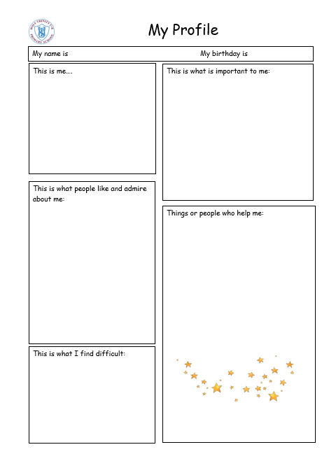

Appendix 2 – My Plan or My Plan +
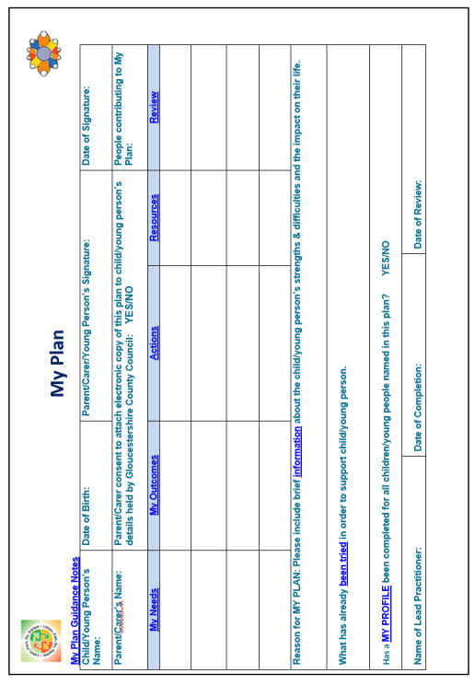
Appendix 3 – A Graduated Approach

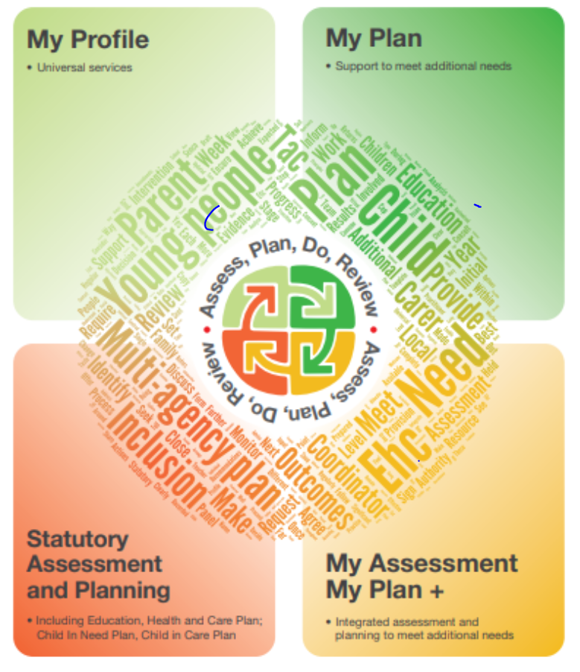

Appendix 4 – Graduated Pathway Flowchart

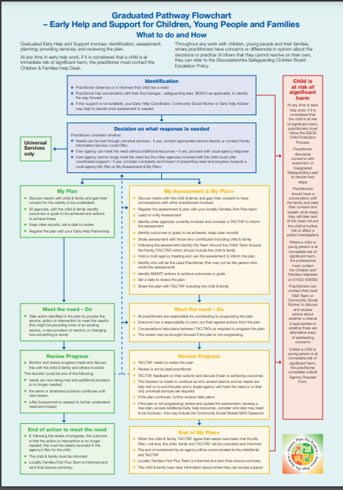

Holy Trinity C of E Primary School
Appendix 5 – The Local Offer
HOLY TRINITY C of E PRIMARY SCHOOL
Local Offer for Children with Special Educational Needs/Disabilities

Our Special Educational Needs Co-ordinator is David Le Templier.
Our Governors with responsibility for SEND is Kate Westmacott.
All Gloucestershire maintained schools follow the statutory SEND Code of Practice (2015) and work within the same countywide approach to identifying and supporting children with Special Educational Needs and Disabilities. Holy Trinity is supported by the Local Authority to ensure that all pupils—regardless of their individual needs—are able to make strong progress and thrive in school.
Holy Trinity is a fully inclusive school. Our ethos places each child at the centre of everything we do, and we tailor support to meet their specific needs so that every pupil can “live life to the full.” We are committed to reducing the attainment gap between pupils with SEND and their peers through high‑quality teaching, early identification, and well‑planned intervention.
We encourage parents and carers to discuss their child’s progress regularly with class teachers. Working together enables us to identify emerging needs as early as possible and put the right support in place at the right time.


